Simple example for coffee machine with symbolic state table:

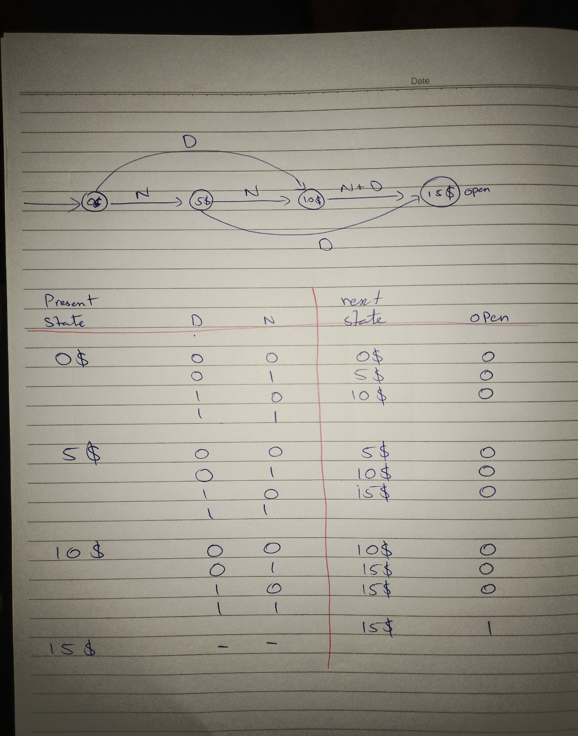

State coding:

D1 = Q1 + D + Q0 N

D0 = Q0’ N + Q0 N’ + Q1 N + Q1 D

OPEN = Q1 Q0

Implementation:

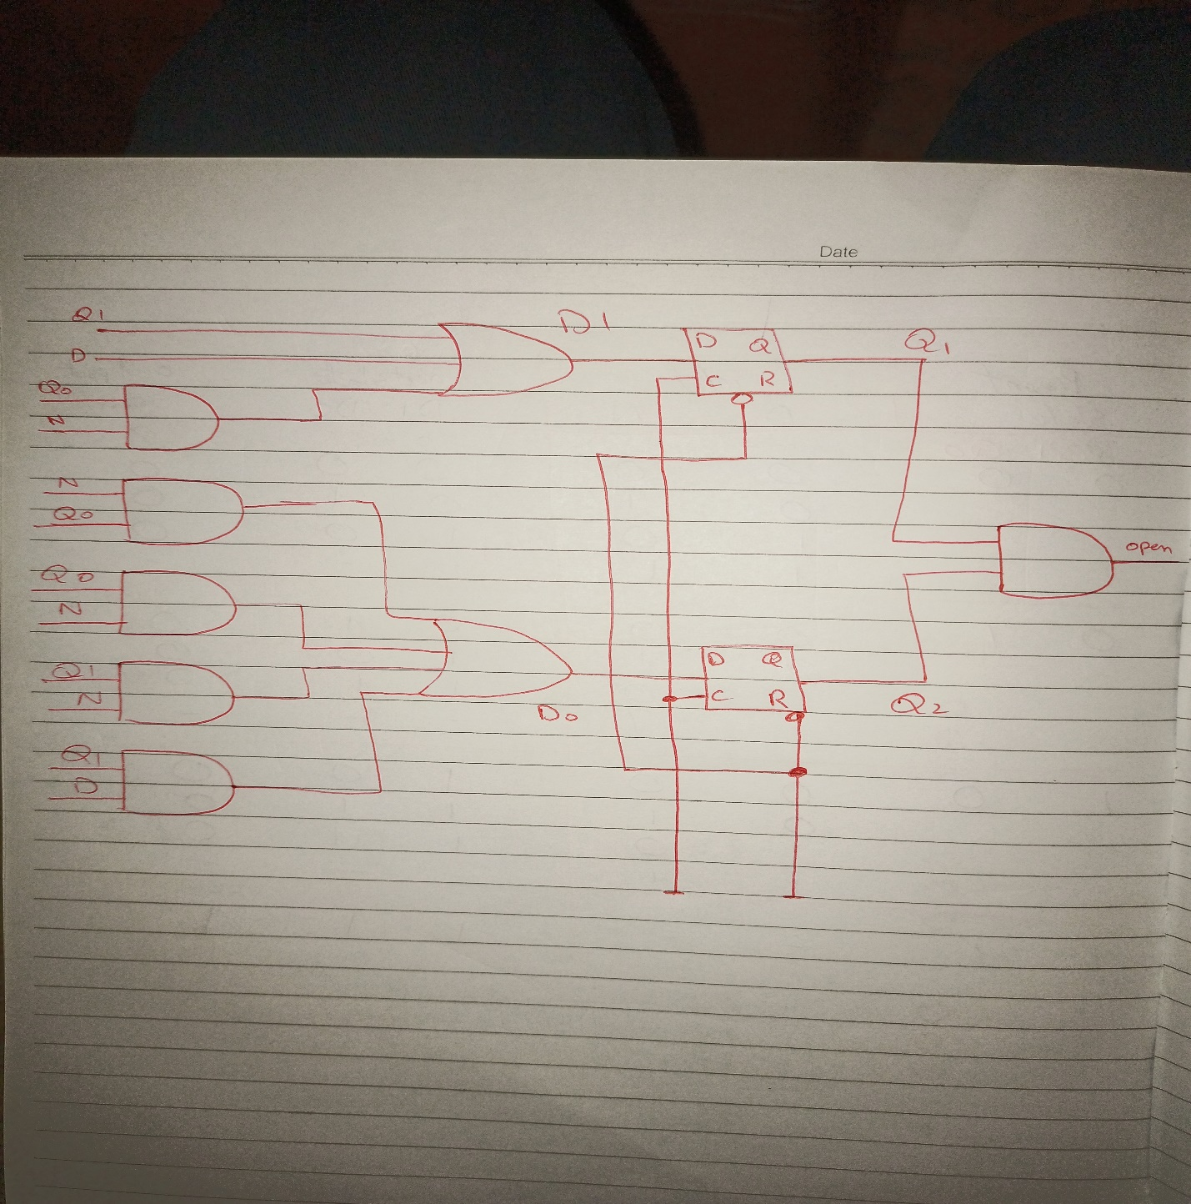

Transition Table:

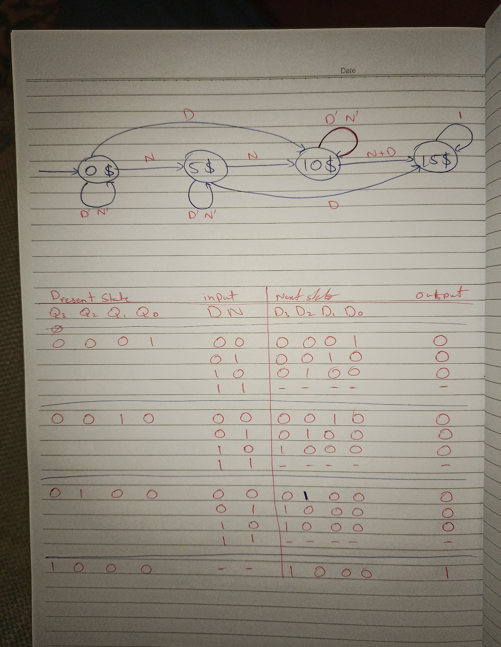

State Diagram:

